|  |  |
| --- | --- |
| cetlogo ***CHEMICAL ENGINEERING TRANSACTIONS***  ***VOL.*** | A publication of  aidiclogo_grande |
| The Italian Association  of Chemical Engineering  Online at www.cetjournal.it |
| Guest Editors:  Copyright © AIDIC Servizi S.r.l. **ISBN** 978-88-95608-xx-x **ISSN** 2283-9216 | |

Poly(3-hydroxybutyrate-co-3-hydroxyvalerate) (PHBV) Based Biocomposites Containing Coffee Silverskin: Injection Moulding and Migration Performances Assessment

Norma Mallegnia\*, Francesca Signoria, Vito Gigantea, Giuseppe Amatob, Luciano Navarinic, Maurizia Seggiania , Patrizia Cinellia\*, Andrea Lazzeria

a Department of Civil and Industrial Engineering, University of Pisa, Largo Lucio Lazzarino 1, 56126 Pisa (Italy)

b LCI Italy Plant 312, Via Etruria 18, San Casciano val di Pesa (FI), Italy.

c Illycaffè S.p.a, via Flavia 110, 34147 Trieste (Italy)

[norma.mallegni@unipi.it](mailto:norma.mallegni@unipi.it), patrizia.cinelli@unipi.it

Poly(3-hydroxybutyrate-co-3-hydroxyvalerate) (PHBV) is among the most attracting low environmental impact polymeric materials. Coffee Silverskin (CS), an agro-food residue, has been compounded in variable amounts into a PHBV matrix in the presence of acetyl tributyl citrate (ATBC) as plasticizer, and calcium carbonate (CaCO3) as filler, to produce biocomposites through a pre-industrial scale melt extrusion technique. Thermal, morphological and mechanical properties have been investigated in order to validate whether these PHBV/CS based biocomposites could be used to manufacture moulded items, e.g. coffee capsules body. The increasing concentration of CS in PHBV improves the stiffness and the heat deflection temperature properties of the biocomposites. Coffee capsules body have been produced by injection moulding starting from the optimized formulations, based on the PHBV/CS system, and were characterized in terms of migration properties in contact with simulants. Notably, the overall migration at 100 °C was below the limit (10 mg/dm2) required for plastic materials in food contact applications.

* 1. Introduction

World plastic consumption increases annually (9% per year), thus there is a high interest to replace the conventional non-biodegradable petro-based plastic, with compostable and possibly carbon dioxide neutral plastics. Petro-plastics have been preferred for their mechanical performances (tensile and tear strength), heat stability, good barrier properties, high availability and a relative low cost (Cinelli et all 2021). Among commercially available biodegradable materials, polyhydroxybutyrate (PHB) and its copolymer (Poly(3-hydroxybutyrate-co-3-hydroxyvalerate) (PHBV) have attracted significant attention by the academia and industries because of their thermo-plasticity and biodegradability behaviour in controlled and uncontrolled environments such as industrial/home composting, and even soil, fresh water and sea water (Deroine et all 2014, Aoyagi et all 2002, Cinelli et all 2019). Polyhydroxyalkanoates (PHAs) are a family of bio-polyesters produced by many bacteria as intracellular storage carbon and energy source against starvation (Seggiani et all 2015). The main limitations in the application of PHAs, is based on their relatively high cost (5–7 €/kg) compared to other polymers (Bugnicourt et all 2015), restricting their use to high-value applications, such as those in medical and pharmaceutical sectors (Bugnicourt et all 2014). PHAs show high stiffness and high crystallinity that guarantee for the good thermal resistance (Wei et all 2015). Notably, PHBVs possess industrial processability similar to that of polypropylene (PP) (Koller et all 1996). The PHBV matrix can be modified by addition of particulate fillers or natural fibers, such as waste fibers such as corn, wheat, bagasse, orange and apple peel (Chiellini et all 2001, Chiellini et all 2004)], abaca, kenaf, hemp, flax, and jute are widely used in the production of composites in various industrial sectors, such as the automotive industry, in order to reduce their cost, promote biodegradability and make them suitable for wider uses such as packaging, and building (Angelini et all 2015, Seggiani et all 2015)). In this framework, the aim of the present study is to design and develop new biodegradable composites based on PHBV by incorporating the raw coffee silverskin (CS), a tegument of green coffee beans, to reduce the cost of the final product as well as to improve their properties towards mitigating the current environmental concerns related to the disposal of this waste. Coffee silverskin, the principal by-product of the roasting process (Ballesteros et all 2007), principally consists of lignin (29 wt.%), cellulose (24 wt.%) and hemicellulose (17 wt.%) (Iriondo-DeHond et all 2017). Although CS has been used for poultry feed and/or as a raw material for paper production, its massive use in value-added applications has so far been limited. To the best of the authors' knowledge, only a few works have been reported on the use of CS embedded into biocomposites, among which some of the noteworthy reports include the study by Zarrinbakhsh et all 2016, Dominici et all 2019, Sarasini et all 2018 and Gigante et all 2020. Following a similar approach, PHBV/CS formulations were here produced by melt extrusion technique and characterized for their thermo-mechanical features. Finally, the optimized PHBV based biocomposites were selected to industrially produce coffee capsules body by injection moulding. Migration tests in contact with foodstuffs simulants were successfully performed on the produced coffee capsules body, in the perspective of their use in food contact applications.

* 1. Experimental

All the starting materials, Poly(3-hydroxybutyrate-co-3-hydroxyvalerate) PHBV (PHI002 by NaturePlast® Caen, France), triturated (to 200 m) coffee silverskin (Illycaffè, Trieste Italy), acetyl tributyl citrate ATBC (Tecnosintesi® Bergamo, Italy), calcium carbonate Omyacarb 2-AV by Omya® (Avenza/Carrara, Italy) were dried at 60 °C for 24 h before extrusion. A composition of 85% PHBV with 10% plasticizer (ATBC) and 5% inorganic filler (CACO3) was selected as fixed polymeric matrix labelled as PCA. In this fixed matrix respectively, a variable content of CS was added, as detailed in Table 1.

Table 1: Compositions of the PHBV/CS prepared biocomposites.

|  |  |  |
| --- | --- | --- |
| Sample | PCA (% w/w.) | CS (%w/w.) |
| PCA | 100 | - |
| PCA\_5 | 95.0 | 5.0 |
| PCA\_7.5 | 92.5 | 7.5 |
| PCA\_10 | 90.0 | 10.0 |
| PCA\_12.5 | 77.5 | 12.5 |

The biocomposites were prepared by melt compounding, using a co-rotating twin-screw extruder (EBC25HT, Comac srl, Cerro Maggiore, Milan, Italy). The extruder, equipped with two 25 mm co-rotating screws in a barrel system with L/D = 44, displayed a temperature profile of 150/165/170/170/170/175/175/175/175/175/175 °C with the die exit zone at 175 °C for PHBV based biocomposites. The screws rate was kept at 300 rpm and mass feed at 15 kg/h. Detailed compositions are reported in table 1. The optimized formulations in terms of processability were used at LCI Italy Plant 312 (San Casciano in Val di Pesa, Firenze, Italy) to produce the coffee capsules body on industrial scale.

* 1. Results

3.1 Mechanical properties

Mechanical behavior of the prepared samples was evaluated by tensile (Fig. 1) and impact tests (Fig. 2). Detailed results are reported in Table 2. Mechanical properties of a commercial poly(propylene), the most applied material for coffee capsules body, are reported for comparison. The incremental addition of CS in PHBV led to an increasing in elastic modulus while a reduction of strength to break was noticed, suggesting a limited interfacial interaction, due to a low compatibility between the polymeric matrix and the CS. By the way PCA with 12.5 wt.% CS content showed a stress resistance and a stiffness within a typical range of materials for injection molding items, included coffee capsules body (Gigante et al 2021). Moreover, it also displayed the greatest impact resistance value, which is around 1.5 times higher than that recorded for raw PHBV.

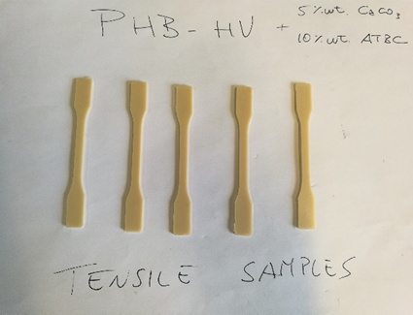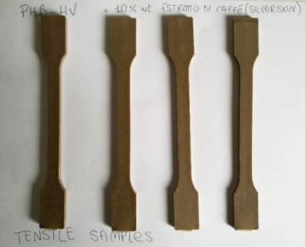

Figure 1: Tensile sample (PCA left, PCA with CS right)

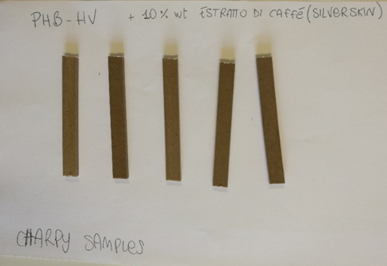

Figure 2: Charpy sample (PCA with CS)

Table 2: Summary of tensile and impact properties for the PHBV/CS composites.

|  |  |  |  |  |
| --- | --- | --- | --- | --- |
| Sample | Elastic Modulus (GPa) | Break Strength (MPa) | Elongation at break  (%) | Charpy Impact Strength (kJ/m2) |
| PP | 1.4±0.05 | 30.0±1.2 | 70.1±0.3 | 7.0±0.9 |
| PHBV | 2.61±0.05 | 34.8±1.1 | 2.6±0.3 | 2.5±0.9 |
| PCA | 1.30±0.06 | 23.0±0.2 | 6.2±0.9 | 5.8±0.6 |
| PCA\_5 | 1.73±0.16 | 20.8±0.7 | 4.0±0.3 | 3.7±0.5 |
| PCA\_7.5 | 1.93±0.17 | 19.7±0.7 | 2.9±0.3 | 3.7±0.4 |
| PCA\_10 | 2.03±0.14 | 18.4±0.9 | 2.5±0.4 | 3.2±0.3 |
| PCA\_12.5 | 2.05±0.12 | 17.3±0.8 | 2.3±0.3 | 3.8±0.2 |

3.2 Heat Deflection Temperature (HDT)

The evaluation of HDT is of pivotal relevance in high temperature applications, such as coffee capsules body. The average values of HDT for the neat PHBV, base matrix PCA and the composite at higher CS content (PCA\_12.5) were found to be 92.2, 78.3 and 80.5°C, respectively. As expected, the addition of ATBC to the PHBV matrix reduced the HDT of neat PHBV. Notably, the formulation with 12.5 wt.% of CS did not show huge differences as compare to the PCA matrix. The observed slight increment in the HDT of PCA\_12.5 with respect to PCA could be due to its higher crystallinity, which ensures a good heat resistance in the sample (Gigante et al 2021). Therefore, the HDT studies demonstrated that PCA and PCA\_12.5 resulted suitable compositions to be applied as biocomposite formulations for the production of coffee capsules body.

3.3 Thermal stability

Weight loss of CS fibres is mainly observed from 230°C to 360°C corresponding to the main thermal degradation process. The onset temperature higher than 300°C confirms that these natural fibres can be processed with thermoplastic polymer matrices, such as PHBV, without incurring in thermal degradation.

3.4 Injection Moulding of the coffee capsules body

The optimized formulations in terms of processability, i.e. PCA and PCA\_12.5, were used at LCI Italy Plant 312 to produce the coffee capsules body on industrial scale by injection moulding (Fig. 3).

Figure3: Examples of the injection moulded coffee capsules body (PCA left, PCA\_12.5 right)

In the industrial injection moulding press was applied a temperature profile: 147/161/170 °C, from the feeding to the end zone of the injection point screw, the mould was set at 22 °C .

3.5 Migration tests on moulded coffee capsules body

The results of the overall migration obtained for moulded capsules body based on and PCA and PCA\_12.5 (Fig. 3) are reported in Table 3. Remarkably, all the tested samples were compliant with current legislation for all the used simulants. Indeed, the average migration values of both formulations are far from the allowed limit of 10 mg/dm2. The test was performed by immersion (Fig. 4) and each simulant was evaluated on three capsules body.

Table 3: Overall migration (OM) test results (100°C, 5 min).

|  |  |  |  |
| --- | --- | --- | --- |
| Formulation | Simulant | OM  (mg/dm2) | Limit  (mg/dm2) |
| PCA | Water | 0.52±0.16 | 10 |
| PCA | Ethanol 10% | 0.55±0.20 | 10 |
| PCA | Acetic Acid | 3.53±1.41 | 10 |
| PCA\_12.5 | Water | 0.99±0.35 | 10 |
| PCA\_12.5 | Ethanol 10% | 0.78±0.39 | 10 |
| PCA\_12.5 | Acetic Acid | 2.77±0.82 | 10 |

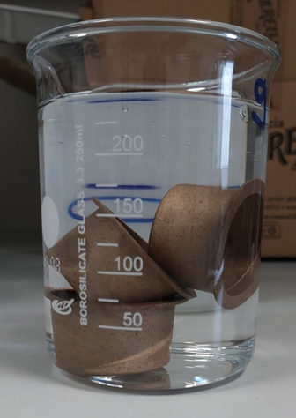

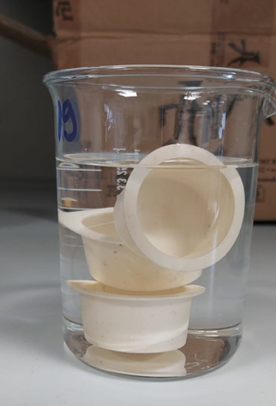

Figure 4: Migration test performed by immersion of injection moulded coffee capsules body (PCA left, PCA\_12.5 right)

The surface of each capsule body was about 3000 mm2, to evaluate the migration in relation to the allowed limits of 10 mg / dm2, the analysis was performed on three capsules body at a time, to reach a total surface area of almost 1 dm2.These results show that during its use at medium and high temperatures, the migration of substances from the moulded capsules body towards the food content (coffee in this case) is totally below the permitted limits. So, the formulations PCA and PCA\_12.5 resulted suitable for thisfood contact applications and therefore, they are also suitable to produce coffee capsules body. Further study are running, such as degradation in compocts that was confirmed to be in the limits indicated by running normative (EN17372).

* 1. Conclusions

In the present work, coffee silverskin (CS), a waste material from coffee production, was incorporated in different amounts (up to 15 wt.%) to PHBV polymeric matrices to produce thermoplastic biocomposites for food-contact applications. The compounded biocomposites were characterized in terms of processability, thermal and mechanical properties in order to investigate whether these PHBV-based biocomposites could be used to manufacture moulded items, such as coffee capsules body. In presence of ATBC as a plasticizer and CaCO3 as an inorganic filler, the developed composites containing CS showed good processability. It is observed that the stress at break and the elongation at break were moderately decreased with the increase of the CS content. On the basis of the obtained good results of migration tests, the developed PHBV based composites can possibly be suitable for the food contact applications and therefore they can be used to produce items for food applications such as coffee capsules body, adopting a circular economy approach.

Acknowledgments

This research was carried out under the project PROLIFIC "Integrated cascades of processes for the extraction and valorization of proteins and bioactive molecules from legumes, fungi and coffee agro-industrial side streams". This project has received funding from the Bio Based Industries Joint Undertaking under the European Union's Horizon 2020 research and innovation program under grant agreement No 790157. Authors acknowledge Laboratori Archa Srl, Pisa, Italy, for carrying out the migration tests and Caldara Plast S.r.l Erba (CO), Italy, for the HDT measurements

References

Angelini L.G., Scalabrelli M., Tavarini S., Cinelli P., Anguillesi I., Lazzeri A., 2015, Ramie fibers in a comparison between chemical and microbiological retting proposed for application in biocomposites. Ind. Crop. Prod., 75, 178–184.

Ballesteros L. F., Teixeira J. A., Mussatto S. I., 2014, Chemical, Functional, and Structural Properties of Spent Coffee Grounds and Coffee Silverskin, Food Bioprocess Tech, 7, 3493-3503.

Bugnicourt E., Cinelli P., Lazzeri A., Alvarez V., 2014, Polyhydroxyalkanoate (PHA): Review of synthesis, characteristics, processing and potential applications in packaging. Express Polym. Lett., 8, 791–808.

Bugnicourt E., Cinelli P., Lazzeri A., Alvarez V., 2015 The Main Characteristics, Properties, Improvements, and Market Data of Polyhydroxyalkanoates. In Handbook of Sustainable Polymers Processing and Applications, Thakur, V.K., Thaku, M.K., Eds., Pan Stanford: 6000 Broken Sound Pkwy, NW, USA, Chapter 24, pp. 899–928.

Chiellini E., Cinelli P., Imam S.H., Mao L., 2001, Composite films based on biorelated agro-industrial waste and poly(vinyl alcohol). Preparation and mechanical properties characterization. Biomacromolecules, 2, 1029–1037.

Chiellini E., Cinelli P., Chiellini F., Imam S.H., 2004, Environmentally degradable biobased polymeric blends & composites, Macromol. Biosci., 4, 218–231.

Cinelli P., Mallegni N., Gigante V., Montanari A., Seggiani M., Coltelli M. B., Bronco S., Lazzeri A., 2019, Biocomposites Based on Polyhydroxyalkanoates and Natural Fibres from Renewable Byproducts. Appl Food Biotechnol 6, 35-43

Cinelli P., Mallegni N., Fiori S., Seggiani M., Coltelli M. B., Righetti M. C., Lazzeri A., 2021, Polylactic acid and poly(butylene adipate-co-terephthalate) blends plasticised with lactic oligomers and epoxy reactive plasticizers, Chemical Engineering Transaction, 88,

Deroine M., Le Duigou A., Corre Y. M., Le Gac P. Y., Davies P., Ce’sar G., Bruzaud S., 2014, Seawater accelerated ageing of poly(3-hydroxybutyrate-co-3-hydroxyvalerate). Polym Degrad Stabil. 105, 237-247.

Dominici F., Garcia Garcia D., Fombuena V., Luzi F., Puglia D., Torre L., Balart R., 2019, Bio-Polyethylene-Based Composites Reinforced with Alkali and Palmitoyl Chloride-Treated Coffee Silverskin. Molecules 24

Gigante V., Seggiani M., Cinelli P., Signori F., Vania A., Navarini L., Amato G., Lazzeri A., 2021, Utilization of coffee silverskin in the production of Poly(3-hydroxybutyrate-co-3-hydroxyvalerate) biopolymer-based thermoplastic biocomposites for food contact applications. Composites Part A: Applied Science and Manufacturing 140, 106172.

Iriondo-DeHond A., Haza A. I., Avalos A., del Castillo M. D., Morales P., 2017, Validation of coffee silverskin extract as a food ingredient by the analysis of cytotoxicity and genotoxicity. Food Res Int 100, 791-797

Koller I., Owen A. J., 1996, Starch-filled PHB and PHB/HV copolymer. Polym Int 39, 175-181.

Sarasini F., Tirillo’ J., Zuorro A., Maffei G., Lavecchia R., Puglia D., Dominici F., Luzi F., Valente T., Torre L., 2018, Recycling coffee silverskin in sustainable composites based on a poly (butylene adipate-co-terephthalate)/poly(3-hydroxybutyrate-co-3-hydroxyvalerate) matrix. Ind Crop Prod 118, 311-320.

Seggiani M., Cinelli P., Verstichel S., Puccini M., Vitolo S., Anguillesi I., Lazzeri A., 2015, Development of Fibres-Reinforced Biodegradable Composites, Chemical Engineering Transaction, 43, 1813-1818.

Wei L. Q., McDonald A. G., 2015, Peroxide induced cross-linking by reactive melt processing of two biopolyesters: Poly(3-hydroxybutyrate) and poly(L-lactic acid) to improve their melting processability. J Appl Polym Sci. 132.

Zarrinbakhsh N., Wang T., Rodriguez-Uribe A., Misra M., Mohanty A. K., 2016, Characterization of Wastes and Coproducts from the Coffee Industry for Composite Material Production. Bioresources 11, 7637-7653.